

Save Game Free

Gold Update

Introduction

Save Game Free is an Awesome free tool for saving and loading game data in Unity Game Engine.

By using Save Game Free you can forgot the process of saving and loading data, you just use our API to do data manipulation.

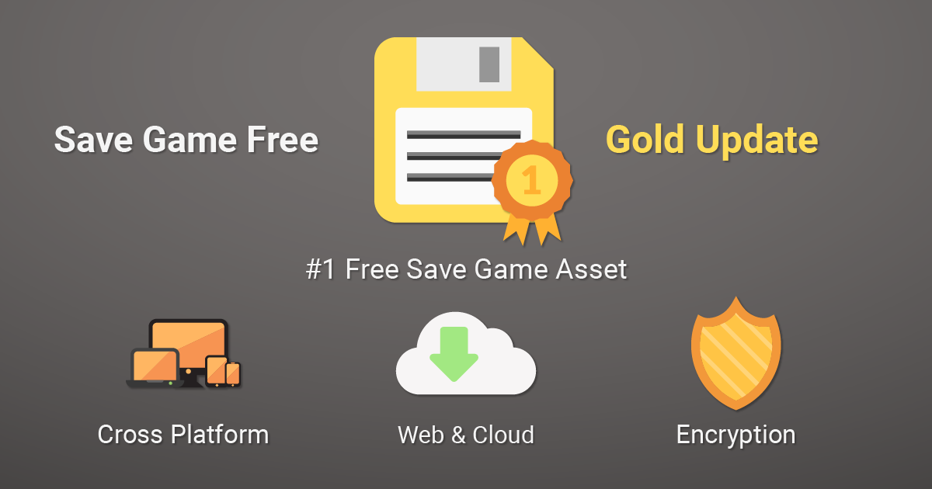

Features

Save Game Free has a lot of awesome features that makes it like professional tool.

- Serialization Flexibility by using Custom Serializers and Built-in Serializers
- Built-in Serializers: Binary, JSON, XML
- Encryption Flexibility by using Custom Encryptions and Built-in Encryption
- Built-in Encryption
- Web & Cloud Support
- Cross Platform (Windows, MacOS, Linux, Android, iOS, tvOS, Samsung TV, Windows Store, missed one? Let us know)
- Awesome Customer Support (Ask anything!)
- Auto Save, An Component that let’s you save objects automatically
- Well Documented: Documented using Code Comments and Online Documentations

Usage

Here is a very simple usage of Save Game Free.

using System.Collections;
using System.Collections.Generic;
using UnityEngine;

public class Example
{

public int score;

void Start ()
{
SaveGame.Save<int> ( "score", score );
}

}

Check out examples at SaveGameFree/Examples folder.

API Documentation

It is a small documentation of Save Game Free API.

SaveGame.Save<T> (string identifier, T obj);

- Identifier: The identifier.
- Obj: The object to save.

SaveGame.Load<T> (string identifier, T defaultValue);

- Identifier: The identifier.
- defaultValue: The default value.

Find more resources at Save Game Free GitHub Page.

Last Words

We are very happy to see you are interesting in using our products.

If you made a game using Save Game Free, you can add it to our Showcase.

If you have any further questions and information, Contact Us, we are here to help.

Show your support by rating and writing a shining review.

Have a nice day!

Goodbye!

